Practical 4 - Automation of File Handling, Backup Creation, and Process Management Using Shell Scripts
1. Aim: -
To write shell scripts to automate basic tasks such as file handling, backup creation, and process management.
2. Requirements: -
Hardware:
- A computer/laptop with minimum 4GB RAM
- Minimum 10GB free disk space
Software:
- Linux Operating System (Ubuntu, or LabEx virtual terminal environment)
- Terminal application (bash shell)
- Text editor: nano (optional, for viewing/editing scripts)
3. Theory
A shell script is a plain text file containing a sequence of Linux commands that the bash interpreter executes one after another, allowing repetitive or multi-step tasks to be automated instead of being typed manually every time. Every script conventionally begins with a shebang line, #!/bin/bash, which tells the system which interpreter should be used to run the file.
Shell scripts can be created in more than one way. A here-document (heredoc), written as cat > file << 'EOF' ... EOF, lets multiple lines be written into a file in a single block, which is convenient but sensitive to exact formatting of the closing delimiter. An alternative is to build the file line by line using echo, where > creates or overwrites a file with a single line of content, while >> appends an additional line to the end of an existing file without erasing what is already there.
This practical automates three common administrative tasks: file handling (creating folders and files), backup creation (copying a directory tree to a backup location using cp -r), and process management (identifying the current user with whoami and listing running processes with ps). Together these illustrate how shell scripting reduces manual, repetitive terminal work to a single reusable command.
4. Procedure: -
The following steps were executed in sequence in a Linux terminal (compatible with both LabEx and a standard Ubuntu terminal). Each step's command(s) are shown below; the corresponding output/screenshot box has been left blank for you to fill in after execution.
Step 1: Create Practical Folder
mkdir shellprac
cd shellprac
pwd
Creates a new folder named shellprac, moves into it, and prints the current working directory to confirm the location (e.g. /home/labex/project/shellprac or /home/student/shellprac depending on the system).
Step 2: File Handling Script
cat > filehandling.sh << 'EOF'
#!/bin/bash
echo "File Handling Started"
mkdir -p datafiles
echo "Hello Linux" > datafiles/file1.txt
echo "Shell Scripting Practical" > datafiles/file2.txt
echo "Files created successfully"
ls -l datafiles
EOF
Now run:
bash filehandling.sh
Writes a script that creates a datafiles folder, writes one line of text into two separate files inside it using output redirection (>), and then lists the folder contents to confirm both files were created.
Step 3: Backup Script (initial attempt - produces a warning)
cat > backup.sh << 'EOF'
#!/bin/bash
echo "Backup Started"
mkdir -p backupcopy
cp -r datafiles backupcopy/
echo "Backup completed successfully"
ls -l backupcopy
EOF
Now run:
bash backup.sh
Writes a script that copies the entire datafiles folder into a new backupcopy folder using cp -r, then lists backupcopy to confirm the copy succeeded. Creating the script this way (via a heredoc) produced a warning on this system - see Section 6 (Error Handling / Troubleshooting) for the cause and the corrected version of this script used in the rest of the practical.
Step 3 (corrected): Backup Script (without warning)
rm -f backup.sh
echo '#!/bin/bash' > backup.sh
echo 'echo "Backup Started"' >> backup.sh
echo 'mkdir -p backupcopy' >> backup.sh
echo 'cp -r datafiles backupcopy/' >> backup.sh
echo 'echo "Backup completed successfully"' >> backup.sh
echo 'ls -l backupcopy' >> backup.sh
Now run:
bash backup.sh
Rebuilds backup.sh line by line using echo with > for the first line and >> for every subsequent line, which avoids the heredoc delimiter issue entirely and produces the same result without any warning.
Step 4: Process Management Script
Typed the following one by one:
rm -f process.sh
echo '#!/bin/bash' > process.sh
echo 'echo "Process Management Started"' >> process.sh
echo 'echo "Current User:"' >> process.sh
echo 'whoami' >> process.sh
echo 'echo "Running Processes:"' >> process.sh
echo 'ps | head -n 5' >> process.sh
bash process.sh
Builds process.sh line by line using echo with output redirection (>) for the first line and append redirection (>>) for every subsequent line, avoiding the heredoc warning seen in Step 3. The script prints the currently logged-in user (whoami) and the first five lines of the running process list (ps | head -n 5).
Step 5: Final Verification
ls
Lists the contents of shellprac to confirm that both scripts and both output folders exist.
Now check files inside datafiles:
ls datafiles
Confirms that file1.txt and file2.txt were created by filehandling.sh.
Check backup folder:
ls backupcopy
Confirms that the datafiles folder was successfully copied into backupcopy.
5. Output of Execution (Screenshots)
Screenshots of the terminal output for each step have been left as placeholders below. Paste the corresponding screenshot/output into each blank box after executing the commands.
Step 1:
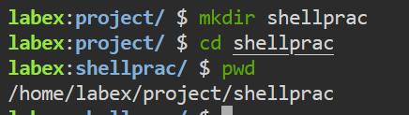
Step 2:
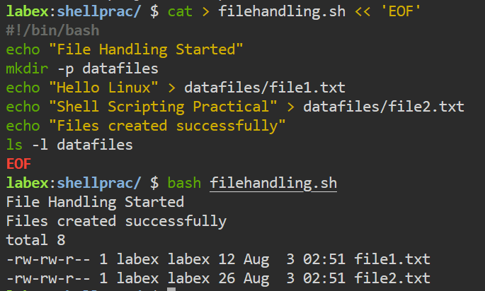
Step 3:
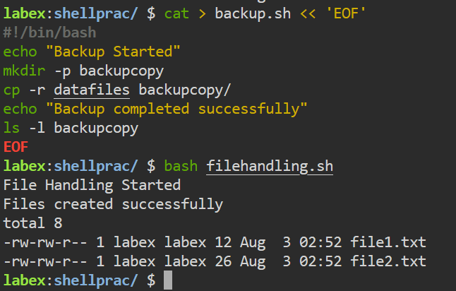
Step 3 (Corrected):
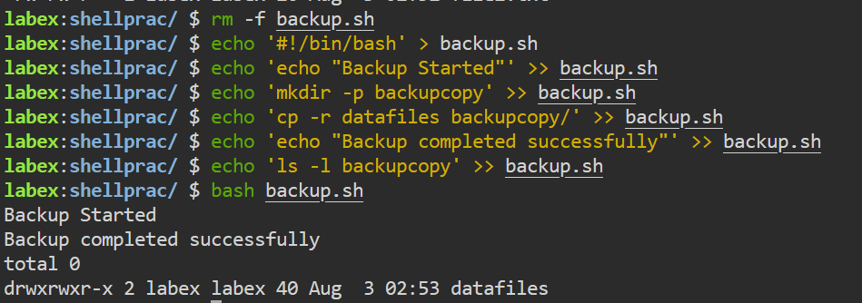
Step 4:
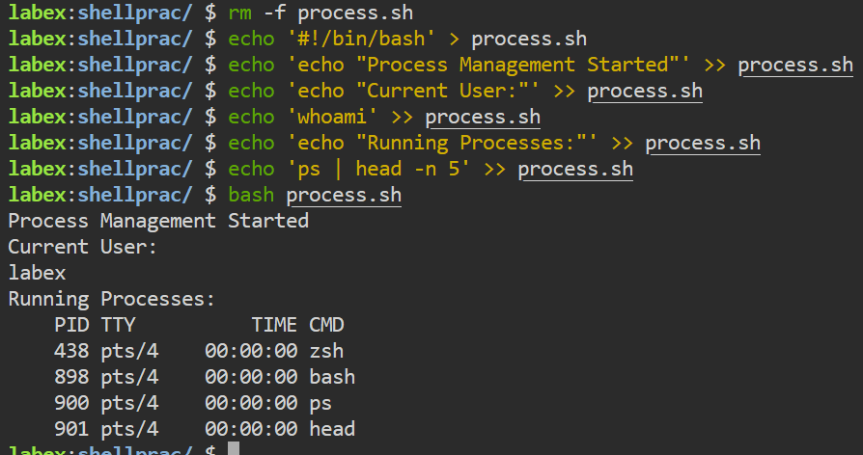
Step 5:
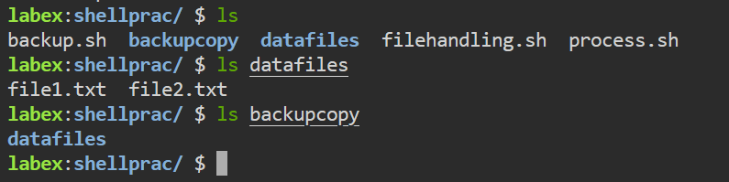
6. Error Handling / Troubleshooting
The following errors/warnings are commonly encountered while performing this practical, along with their cause and fix:
Error: Backup script written using a here-document (cat > backup.sh << 'EOF' ...) produced a warning when executed.
  - Handling: Removed the file with rm -f backup.sh and rewrote the script line-by-line using echo '...' > backup.sh for the first line and echo '...' >> backup.sh for each subsequent line, which executed cleanly without warnings.
7. Important Insights
- A script only needs to be readable and passed to an interpreter to run (bash script.sh) - execute permission and the #!/bin/bash shebang are only required when running it directly as ./script.sh.
- Heredocs (<< 'EOF' ... EOF) are convenient for writing multi-line scripts in one block, but the closing delimiter must match exactly (no trailing spaces, no indentation) or bash keeps reading past the intended end of the file.
- Building a script line by line with echo avoids heredoc formatting pitfalls: > creates/overwrites the file with the first line, and >> appends every line after that.
- cp -r is required (not plain cp) when copying an entire directory and its contents, as used in the backup script.
- whoami and ps are simple but effective process-management commands - whoami identifies the current user, while ps | head -n 5 gives a quick snapshot of running processes without listing the entire process table.
- Automating a task with a shell script makes it repeatable and consistent - the same file-handling, backup, and process-check steps can be re-run at any time with a single command.
8. Conclusion
This practical demonstrated how shell scripting can automate basic Linux administrative tasks. A working folder named shellprac was created, inside which three shell scripts were written. The first script, filehandling.sh, automatically created a folder and two data files. The second script, backup.sh, copied that folder into a backup location; an initial attempt written using a heredoc produced a warning, which was resolved by rebuilding the script line by line with echo. The third script, process.sh, displayed the current user and a snapshot of running processes. Together, these scripts show how repetitive Linux tasks - file handling, backup creation, and process management - can be automated and made consistently repeatable using shell scripting.
9. Viva Questions
Q1. What is a shell script and why is it used?
A shell script is a text file containing a sequence of Linux commands that the shell executes in order. It is used to automate repetitive or multi-step tasks so they can be run consistently with a single command instead of being typed manually each time.
Q2. What is the purpose of the #!/bin/bash line at the top of a script?
This line is called the shebang. It tells the operating system which interpreter (in this case, bash) should be used to execute the commands in the script when the script is run directly.
Q3. What is the difference between > and >> in shell scripting?
The > operator redirects output into a file, creating it if it does not exist and overwriting its existing content if it does. The >> operator appends output to the end of a file, keeping any existing content intact.
Q4. Why did the heredoc-based backup.sh produce a warning, and how was it fixed?
The warning occurred because the closing EOF delimiter of the heredoc was not recognised exactly as written, which is a common heredoc formatting issue. It was fixed by rebuilding the script line by line using echo with > for the first line and >> for every subsequent line, which avoids heredoc delimiter issues entirely.
Q5. What do the commands whoami and ps do?
whoami prints the username of the currently logged-in user. ps lists the processes currently running in the terminal session, showing details such as process ID (PID), terminal (TTY), CPU time, and command name (CMD).
10. References: -
- Practical reference document (course material) - https://docs.google.com/document/d/1NBZIxKOG4weVhsjOGzZYS-olCmyzyENaNSgQydzsBF0/edit?tab=t.0

